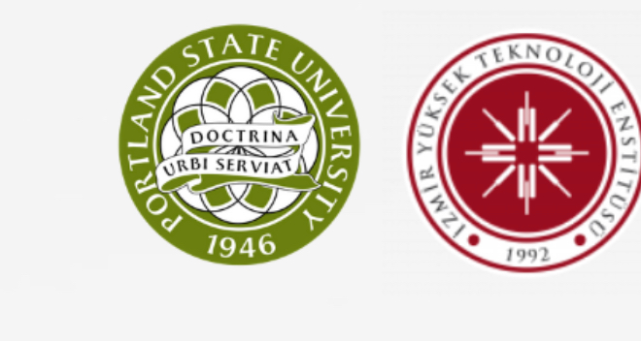

TDIM (Technology Design and Innovation Management) and ETM (Engineering Technology Management) of PSU intent to elevate present cooperation to a higher level within the framework of a MoU between İzmir Institute of Technology and Portland State University (PSU)

(1) Visits by faculty and students from one university to the other for the purpose of consultation, in research or other educational activities;

(2) The enrollment of qualified students from one university in undergraduate and graduate programs at the other university;

(3) A sharing of academic publications and scholarly information; and

(4) The promotion of other academic activities which enhance the above mentioned goals.